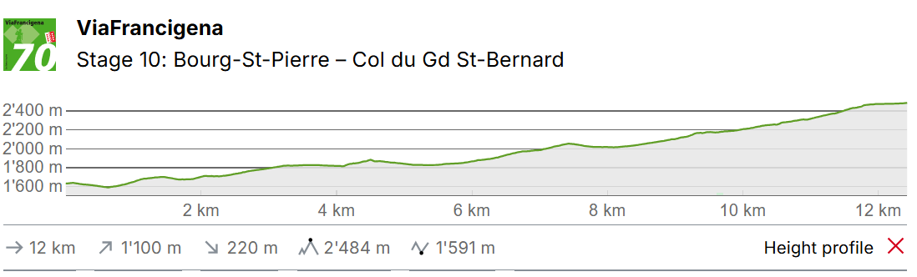
Bourg St Pierre – Col St Bernard

This is certainly the most symbolic stage of the Via Francigena. The route to the pass is via a road that has been used by the whole of Europe for 2,000 years. Numerous archaeological sites line the ascent, notably in L'Hospitalet and at the Barasson Pass.
Bourg-St. Pierre is located in the Val d'Entremont. The village exudes a great deal of charm with its old buildings and restored mill. Traces and legends lie hidden in the walls; a testimony to its vibrant activity over the centuries. Hannibal and his elephants passed through here, as did the troops of the Roman Empire, Napoleon’s soldiers, and millions of pilgrims and traders.
You leave the pretty village along the old exterior walls and follow a gravel road to the dam. The reservoir with a storage capacity of 20 million m3 is mainly fed by the river Dranse. The arch dam is 460 metres wide and 86 high. The first floating solar plant in Switzerland and the highest in the world is located on the lake. Due to the altitude and the thinner air, the sun’s rays are particularly intense. The sun is additionally reflected by the water and snow, which is why the double-sided solar panels supply 50% more electricity than comparable systems in the lowlands. An attractive path with blooming alpine flora runs above the reservoir to the beginning of the lake, where you can visit the solar plant.
The path continues to follow the Dranse. You can see the entrance to the tunnel in the valley. Anyone not wishing to drive over the pass can cross the border to Italy through the mountain. The path meanders on in all its diversity on the way towards the Great St. Bernard. The Great St. Bernard is located at an altitude of 2,469 m. It is the third highest pass in Switzerland and forms the most important connection between French-speaking Switzerland and Italy. Its name came from St. Bernard, who founded the hospice there around 1050.
You cover the altitude difference, partly along the Dranse and partly via the pass road. After a good four hours, you reach the hospice and the pass crossing. Arriving at an altitude of 2,469 metres, what is probably the most symbolic stage of the Via Francigena is now complete. On the Italian side, the route goes down through the Aosta Valley to Ivrea, crossing the Po Valley, the Apennines and Tuscany. After a total of 52 stages full of cultural and culinary discoveries, you arrive in Rome via the Via Trionfale.

Accomodation Col du Gd St Bernard
58.83 with dinner and breakfast
42.54 with just breakfast
